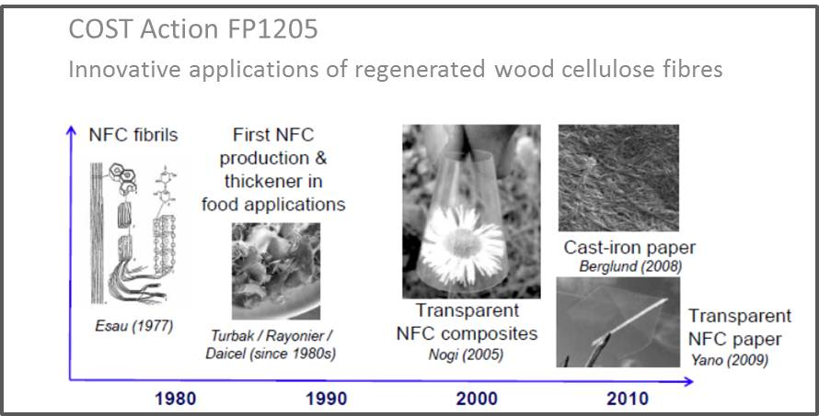

COST FP1205/EPNOE Joint Workshop
Conference Center of the National Stadium in Warsaw,
Al. Ks. J. Poniatowskiego 1, Warsaw, Poland
Sunday 18th October 2015
Pre Conference Workshop:
Physics and Chemistry in Polysaccharide Science: From Molecules to Materials
REGISTRATION FORM and CALL FOR POSTERS

EPNOE International Polysaccharide Conferences are now key features of the calendar of European scientific events. The conference has been organized biannually since 2009. The conference aim is to bring together students, scientists and specialists working in industry, universities and research institutes to exchange experiences, present research results, develop a platform for mutual scientific contacts and intensify academic/industry cooperation.

Since 2013, the EPNOE International Polysaccharide Conference has been promoted and organized jointly by the European Polysaccharide Network of Excellence (EPNOE) and the Cellulose and Renewable Materials division of the American Chemical Society (ACS).

On behalf of EPNOE and ACS, we have the pleasure to invite you to participate in the 4th Conference EPNOE 2015 “Polysaccharides and Polysaccharide-based advanced materials: From Science to Industry” which will be held from 19 to 22 October 2015 in Warsaw, Poland. EPNOE 2015 is organized by the Institute of Biopolymers and Chemical Fibres (IBWCh), Warsaw, Poland on 19-22 October 2015.

Before the main EPNOE conference, there will be a pre-conference workshop on “Physics and Chemistry in Polysaccharide Science: From Molecules to Materials” organised on Sunday 18 October, 2015 in the Conference Center of the National Stadium in Warsaw, Al. Ks. J. Poniatowskiego 1.

This one day meeting will focus on a series of talks from a range of experts. However there will be opportunities to present posters at the event.

The programme for the one-day meeting is as follows:

Sunday 18th October 2015
09:00 | Registration
09:00  09:10  09:45 | Welcome  Course 1: Jan van Dam: Polysaccharides and building  Course 2: Kevin Edgar: Glycosaminoglycans: Polysaccharides as language
10:20 | BREAK
10:35  11:10  11:45 | Course 3: Orlando Rojas: Multiphase systems, relevance and measuring tools  Course 4: Karin Stana Kleinschek: Polysaccharide uses in biomedical applications  Course 5: Tatiana Budtova: Natural fibre reinforced polymer composites
12:20 | LUNCH and POSTER SESSION
14:30  15:05 | Course 6: Pedro Fardim: Engineering Polysaccharides for Health Care  Course 7: Bernard Cathala: Cellulose model surface: elaboration, characterisation and applications
15:40 | BREAK
16:00  16:35 | Course 8: Laurent Arnaud: Bio based building materials: from microstructure to technical performances.  Course 9: Patrick Navard: Rheology of isotropic and liquid crystalline cellulose-based solutions
17:10 | END

This course has a fee of 50€/person for undergraduate and PhD students and 100€/person for others.

Joint EPNOE/COST FP1205 Meeting
Warsaw, Poland
18th October 2015
One day Pre-Conference Workshop:
Physics and Chemistry in Polysaccharide Science: From Molecules to Materials
MEETING REGISTRATION FORM

All participants: please provide name and contact details -one form per participant please
Family name: |  |  |  |  |  | First name:
Company name:
Address:
City: |  |  |  |  |  | Postal code:
Country: |  |  |  |  |  | State/County:
Phone: |  |  |  |  |  | Fax:
E-mail:
Early stage researcher*: YES/NO (delete as appropriate)
Poster Presentation: YES/NO (delete as appropriate)
Title_____________________________________________________________________________________________
______________________________________________________________________________________________
Sex: Male / Female (delete as appropriate, for statistical purposes)

Dietary requirements:____________

Registration
To register:
- Complete and return this form and send it to Sylvie Massol (sylvie.massol@mines-paristech.fr) and Dennis Jones (dennis.jones@sp.se).
- Register on the epnoe2015 conference official site: http://epnoe2015.ibwch.lodz.pl/

*ESR defined as someone still undertaking MSc/PhD studies or having completed studies within past 8 years.

Preparing an abstract for the Joint EPNOE / COST FP1205 Workshop “Physics and Chemistry in Polysaccharide Science: From Molecules to Materials”
Dennis Jones
SP Technical Research Institute of Sweden, Drottning kristinas väg 67, 114 86 Stockholm, Sweden. E: dennis.jones@sp.se
Keywords: 3 to 7 keywords in alphabetical order
abstract
Please limit the text (including diagrams, tables and references) to maximum two pages, use 12 pt Times Roman font, justified. Cite references in the text using the author’s last name and date of publication as follows (Jones 1999, Jones and Evans 1997, Jones et al. 2003). List citations in alphabetical order at the end of the manuscript (examples are given at the end of this document). Please use full journal titles and not abbreviations. Place figure captions below the figure (use Times Roman 10 pt bold, centred) and refer to as Fig. X in the text, place table captions (use Times Roman 10 pt bold, centred) above the table, refer to as Table X. The deadline for receipt of abstracts is the 21 August 2015.

Figure 1: This is the title of Figure 1.

Table 1: This is the title of Table 1.

Use the recommended styles for references. Do not use End Note.

REFERENCES

Green, F., Clausen, C.A., Micales, J.A. Highley, T.L. and Wolter, K.E. (1989). Carbohydrate-degrading complex of brown-rot fungus Postia placenta: Purification of β-1,4-xylanase. Holzforschung, 43(1), 25-31.

